# PROJECT REPORT TEMPLATE

## 1. INTRODUCTION

## 1.1 OVERVIEW

An index of economic freedom is a composite measure of the quality of political-economic institutions across different jurisdictions. Scores and ranks in an index are based on criteria that the creators of the index judge as being relevant, which vary from one index to another.

### 1.2 PURPOSE

The indexes of economic freedom that these economists developed combine qualitative and quantitative data about the laws, regulations, taxes, and general economic policies of different countries into a composite score for each country and an overall ranking across countries.

# 2. PROBLEM DESIGNING & DESIGN THINKING

## 2.1 EMPATHY MAP

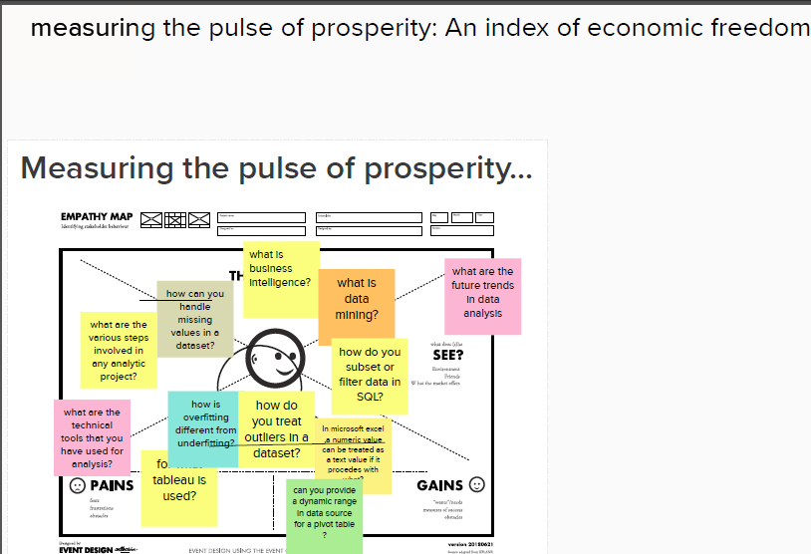

3. RESULT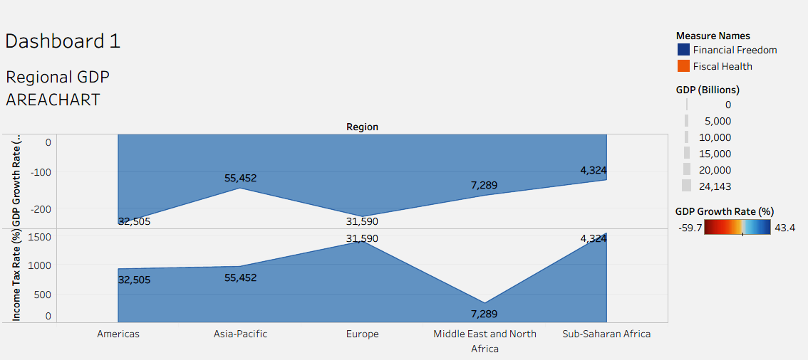

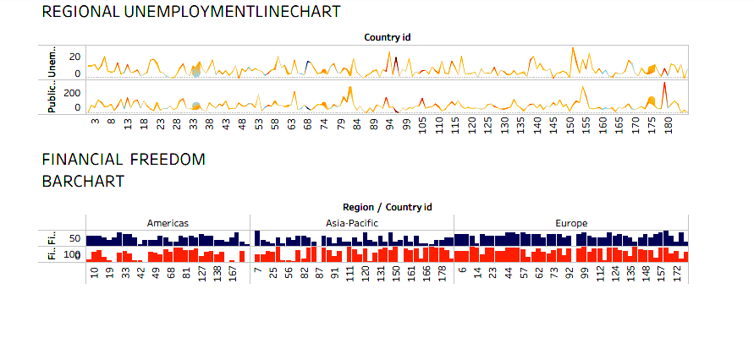

## 4. ADVANTAGES & DISADVANTAGES

ADVANTAGES

These indexes are motivated by the observation that economies that are more free-market based tend to experience greater levels of investment, more rapid growth, and higher average incomes.

# DISADVANTAGES

1. Poor Quality

2. Merit goods

3. Excessive Power of Firms

4. Unemployment and Inequality

# 5. APPLICATIONS

Investors can use the index of economic freedom as a quick way to monitor the changes in economies where they are interested in exposure.

The index of economic freedom can provide a guide as to whether the potential for hot emerging market picks like the [BRIC nations](https://www.investopedia.com/terms/b/bric.asp) (Brazil, Russia, India, and China) are actually seeing the policy changes necessary for that growth to benefit international investors.

# 6. CONCLUSION

 The most widely referenced index of economic freedom is produced by the Heritage Foundation, a conservative American think tank. The Fraser Institute, a Canadian think tank, also publishes a well-known index of economic freedom.

# 7. FUTURE SCOPE

For twenty-nine years the Index has delivered thoughtful analysis in a clear, friendly, and straight-forward format. With new resources for users and a website tailored for research and education, the Index of Economic Freedom is poised to help readers track over two decades of the advancement in economic freedom, prosperity, and opportunity and promote these ideas in their homes, schools, and communities.